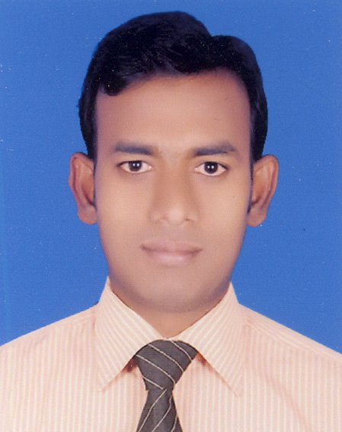
RESUME

Name (English) : Mahadi Hasan
Name (Bangla) : ‡g‡n`x nvmvb
Father’s Name : Ismail Hossen
Mother’s Name : Sofura Khatun

Address:

Present : Vill. + P. O. : Debnagor ( 9400 ),
Upazila : Satkhira Sadar, P. S. : Satkhira,
District : Satkhira.

Permanent : (Do).

Contact : Cell NO. : +880 01714949547
E-mail : mahadibtis@gmail.com

Personal Information:

Date of birth : 5th March, 1988
Religion : Islam
Nationality : Bangladeshi by birth.
National ID NO. : 8718281395100
Marital status : Single
Height : 5´5˝
Weight : 62 kg.
Blood Group : A⁺
Health : Sound and capable to undertake any
Challenging assignment.

Academic Qualification:

Exam Title | Passing Year | Roll NO. | Registration NO. | Institute | Board / Address | Group / Dept. | Result | Scale | Duration
M.T.I.S. | 2011 | 0601056 | 56 | Islamic University | Kushtia | M.T.I.S | CGPA 3.54 | 4 | One Year
B.T.I.S. (Honours) | 2010 | 1000156 | 56 | Islamic University | Kushtia | B.T.I.S | CGPA 3.11 | 4 | Four Years
H. S. C. | 2006 | 527471 | 881633 | Advocate Abdur Rahman College | Jessore | Humanities | GPA 3.80 | 5 | Two Years
Dakhil | 2004 | 182906 | 328557 | Raznagor Islamia Dakhil Madrasha | Madrasha Board, Dhaka | Humanities | GPA 4.33 | 5 | Two Years

Computer Literacy:

* Course : Diploma in Computer Science.
* Environment : Windows (98/2000/Xp/7/8).
* Applications : MS Office, Photoshop, Video editing etc.
* Other Expertise : Fast & Efficient internet browsing, mailing
& online working.

Language:

* Can speak and write Bangla.
* Can speak and write English.

Experience:
* As a Credit Officer (CO), BRAC Progoti Programme.
Form 01/01/2017 to 05/09/2019
*As a RO (Relationship Officer), Brac Bank Ltd. From 08/09/2019 to till now
Why I deserve this post:

I am honest and intelligent, diligent and ready to go extra leg to achieve the target. I have set for myself. I am a natural team player and can lead and be lead as the situation requires. I am optimist by nature and have a good sense of humor. I want to perform my duties in time. I am disciplined and believe in work than fate.

Reference:

Kazi Asaduzzaman  Head of asset & ROC Operation  BRAC Bank, Ltd.  Mob-01730332999 | MD. Abul Kalam Azad  Editor  The Daily Patradoot,  Satkhira.  Mob- 01711 822557
Mirajul Islam  RO. Unit in charge  Arpara SME unit  Mob- 01700714545 | Prof. Dr, Akbar Hossain  Dept, of Al Quran & Islamic Studies.  Islamic University, Kushtia  Mob- 01712946096



-----------------------
( Mahadi Hasan )

